

International Journal on Advanced Vocational   
Information and Communication Technology

Homepage: <https://research.isas.or.id/index.php/IJAVICT/>

**International Journal on Advanced Vocational Information and Communication Technology**

Year: 20xx, Volume: xx, Number: x, Pages: x-xx

# **Paper’s Title Should Be the Fewest Possible Words That Accurately Describe the Content of The Paper (Cambria, Center, Bold, 16pt)**

Author Name1*, Author Name2, Author Name3

1Author Affiliation, Country

2Author Affiliation, Country

*Corresponding Author: [email@xx.yy](mailto:email@xx.yy)

|  |  |
| --- | --- |
| **Article Info** | **Abstract** |
| ***Article History:***  *Submitted/Received 00 xxx 2025*  *First Revised 00 xxx 2025*  *Accepted 00 xxx 2025*  *First Available Online 00 xxx 2025*  *Publication Date 00 xxx 2025*  ____________________  ***Keyword:***  *Keyword 1,*  *Keyword 2,*  *Keyword 3,*  *Keyword 4,*  *Keyword 5,*  *Keyword 6.* | An abstract is a standalone summary that serves as a crucial gateway to the article. A well-structured abstract enables readers to quickly grasp the core content, assess its novelty, and determine its relevance before engaging with the full text. It should provide a concise yet comprehensive overview, including a clear statement of the problem, the proposed innovative approach or solution, and the key findings and conclusions. The abstract should be between 100 and 250 words and should generally avoid references unless absolutely necessary; in such cases, the author's name and year should be cited. Standard terminology should be prioritized, while non-standard or uncommon abbreviations should be minimized and defined at first mention. Keywords, typically ranging from five to seven, enhance discoverability through indexing and abstracting services, complementing the terms already present in the title. No direct citations from the literature should be included in this section. (12 pt). |
|  | © 2025 Indonesian Society of Applied Science (ISAS)  This is an open access article under the **CC BY 4.0** license |

## 1. Introduction

The main text of the manuscript should be formatted into flat left-right columns on A4 paper (quarto). The margins are set to 2.0 cm for the top, and 2.5 cm for the right, left, and bottom. Manuscripts must be prepared using Microsoft Word, single-spaced, in Cambria font, size 12 pt. The maximum length is 15 pages for original research articles or 20 pages for review/survey papers. Detailed formatting instructions can be downloaded from the website: <https://research.isas.or.id/index.php/IJAVICT/>.

The article title must be concise, accurately reflecting the content of the paper, and should not exceed 15 words. Avoid using acronyms, abbreviations, or methods unless the article introduces a novel method. Titles play a crucial role in information retrieval systems, so long formulas with subscripts and unnecessary words like "*A study of ...*", "*Investigations of ...*", "*Implementation of ...*", "*Effect of ...*", or "*Analysis of ...*" should be omitted.

A concise and objective abstract is mandatory, summarizing the research's purpose, primary findings, and major conclusions. Since abstracts are often read independently of the full text, they must be self-explanatory. References should generally be avoided unless indispensable, in which case the author(s) and year(s) must be cited. Non-standard abbreviations should also be avoided, but if necessary, they must be defined when first mentioned. After the abstract, provide 5 to 7 keywords for indexing purposes, using American spelling and avoiding general or plural terms, as well as multi-concept keywords like “*and*” or “*of.*” Keywords enhance discoverability through indexing and abstracting services, so they should be carefully selected.

Indexing and abstracting services heavily rely on an accurate title to extract relevant keywords for cross-referencing and searches. Papers with ambiguous or poorly written titles may fail to reach their intended audience, emphasizing the importance of precision.

The Introduction section should clearly provide: i) a well-defined background, ii) a concise statement of the research problem, iii) a review of relevant literature (related work) to contextualize the study, iv) the proposed approach or solution, and v) the novelty and contribution of the research (presented within 3–6 paragraphs). This section should be written in a manner that is accessible to readers from a wide range of scientific disciplines.

The bibliography should be organized and cited following the Institute of Electrical and Electronics Engineers (IEEE) citation style, denoted by brackets, e.g., [1], [2]. Terms in foreign languages should be italicized (*italic*) [3]. The text must be divided into sections with distinct headings, each numbered consecutively, e.g., **1. Introduction**.

A complete manuscript generally follows a structured format that ensures clarity and coherence. The **Introduction** includes the background, a concise problem statement, and a review of related work to emphasize the uniqueness and significance of the study. If the research introduces an innovative approach, the section on **The Comprehensive Theoretical Basis** and/or the **Proposed Method/Algorithm** (***optional***) provides a detailed explanation of the theoretical framework or the new method/algorithm. The **Method** section describes the research design, methodology, and procedural steps undertaken during the study. Following this, the **Results and Discussion** section presents the findings, accompanied by a comprehensive analysis and interpretation of their implications. Finally, the Conclusion summarizes the key outcomes, highlights the contributions of the research, and suggests potential directions for future work.

This structure, commonly referred to as the “**IMRaD**” style, ensures clarity and logical progression, with the “related work” typically embedded in the Introduction section to differentiate the study from prior research.

The literature review should be incorporated in the “**Introduction**” section to highlight how the manuscript differs from existing works and demonstrates its novelty. It should also be utilized in the “**Method**” section to describe the research steps and in the “**Results and Discussion**” section to support the analysis [2]. Manuscripts with high originality, such as those proposing a new method or algorithm, may include an additional section after “**Introduction**” and before “**Method**” to briefly explain the theory or the proposed method/algorithm [4].

## 2. Methods

Explaining research chronological, including research design, research procedure (in the form of algorithms, Pseudocode or other), how to test and data acquisition [5], [6], [7]. The description of the course of research should be supported references, so the explanation can be accepted scientifically [8], [9]. Figures 1-2 and Table 1 are presented center, as shown below and cited in the manuscript [5], [10], [11], [12], [13], [14], [15]. The settlement curves produced at SG1 has been illustrated in Figure 2(a) and SG2 has been illustrated Figure 2(b).

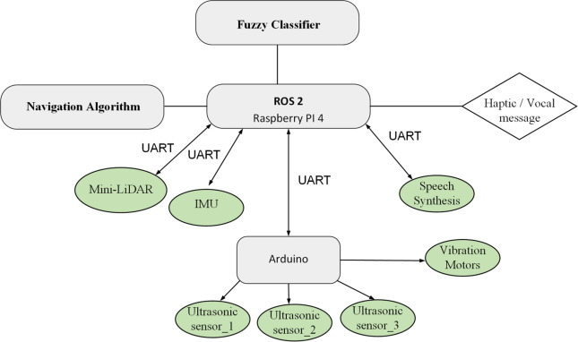

**Figure 1.** Title of the figure 1 …

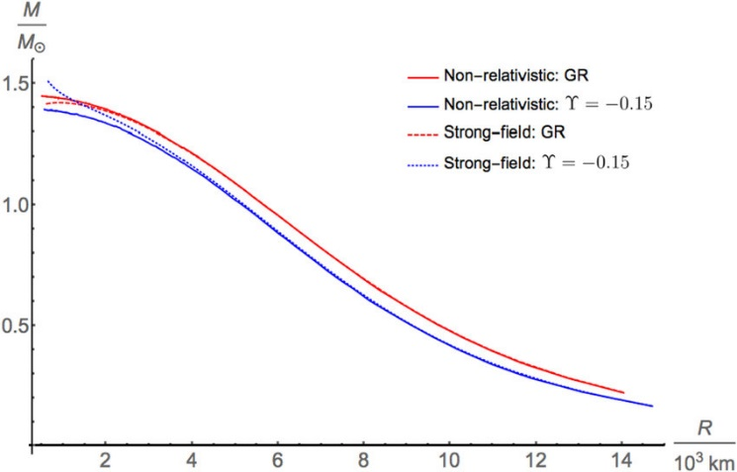

(a)

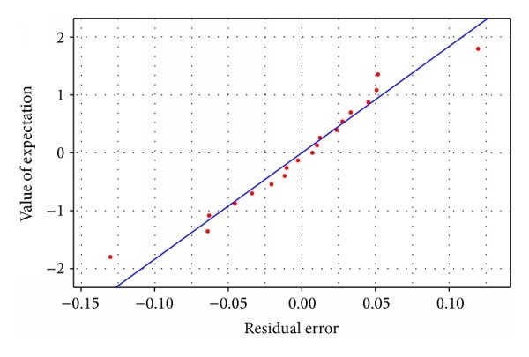

(b)

**Figure 2.** Title of the figure 2 … (a) Subtitle of the figure a ... and (b) Subtitle of the figure b ...

**Table 1.** Simulation Parameters

|  |  |  |
| --- | --- | --- |
| **Parameters** | **Symbol** | **Value** |
| Parameter 1 | $$E_{0}$$ | 0.5 J |
| Parameter 2 | ɛfs | 10e-12 J/b |
| Parameter 3 | ɛmp | 0.0013e-12 J/b |

**Algorthm 1.** Title of the algorithm …

|  |
| --- |
| **Require:**  1: $….$ 2: ….  3: ….  **Ensure:**  4: ….  5: ….  6: …. |

## 3. Results and Discussion

This section presents research findings and provides a comprehensive discussion. Results should be clearly structured using figures, graphs, and tables for ease of understanding [16], [17]. Each figure and table must be referenced and explained thoroughly in the text.

### 3.1. Formatting Equations

Mathematical equations should be center-aligned and numbered sequentially, as demonstrated in Equation (1). Use the Microsoft Equation Editor or MathType to ensure proper formatting.

$T\left(i\right)=\left\{\begin{aligned}\frac{p}{1-p\left[r×mod\left(\frac{1}{p}\right)\right]} , \text{if node }i∈G \\ 0 , \text{otherwise }\end{aligned}\right.$ (1)

All symbols and variables used in equations should be explicitly defined in the following text to avoid ambiguity.

### 3.2. Citation and Referencing Guidelines

1. Authors must ensure proper citation of previous research to maintain academic integrity and avoid plagiarism. When referring to prior studies, numerical citations within brackets should be used, such as [18] or [19]. If multiple references are cited, they should be separated by commas, for example, [18], [19]. When a reference appears at the beginning of a sentence, “Ref [20]...” should be used instead of only a bracketed number. For sources with three or more authors, list only the first author’s name followed by “*et al.*,” as in “McDonnell et al., 2019.” The reference list at the end of the manuscript should follow the IEEE citation style and be formatted in a 12 pt font size [22], [23], [24], [25], [26], [27].

#### 3.2.1. Sub-subsection Title

Content explaining specific aspects of the research.

#### 3.2.2. Sub-subsection Title

Further details and elaboration of key points.

## 4. Conclusion

The Conclusion section should be written concisely and clearly, highlighting the main findings of the research without excessively repeating content from the Results and Discussion section. It should begin with a summary of the key research findings, directly addressing the study's objectives. This section should also emphasize the contribution and implications of the study, whether theoretical, practical, or policy-related, ensuring that the significance of the research is well understood.

If applicable, the conclusion may briefly mention the limitations encountered during the study. However, these should not be overly emphasized but rather presented as opportunities for improvement. Additionally, providing recommendations for future research is essential, offering suggestions on potential areas for further exploration, such as improved methodologies, broader data coverage, or additional factors that were not considered in the current study.

The conclusion should be written in paragraph form, without subheadings or bullet points, and should typically be limited to one to three paragraphs, depending on the complexity of the research. References should be avoided in this section, as it should solely summarize the research findings. The language should be assertive and objective, avoiding speculative statements that are not supported by the study’s results.

## 5. Acknowledgment

The authors would like to express their gratitude to all parties who contributed to the completion of this research. Special thanks are extended to [**specific individuals, institutions, or funding sources, if any**] for their support and assistance throughout this study.

## 6. Author’s Note

The authors hereby declare that there is no conflict of interest related to the publication of this article. Furthermore, the authors confirm that the manuscript is original and free from any form of plagiarism.

## 7. References

[1] M. Sigala, A. Beer, L. Hodgson, and A. O’Connor, *Big Data for Measuring the Impact of Tourism Economic Development Programmes: A Process and Quality Criteria Framework for Using Big Data*. 2019.

[2] G. Nguyen *et al.*, “Machine Learning and Deep Learning frameworks and libraries for large-scale data mining: a survey,” *Artif Intell Rev*, vol. 52, no. 1, pp. 77–124, 2019, doi: 10.1007/s10462-018-09679-z.

[3] C. Shorten and T. M. Khoshgoftaar, “A survey on Image Data Augmentation for Deep Learning,” *J Big Data*, vol. 6, no. 1, 2019, doi: 10.1186/s40537-019-0197-0.

[4] R. Vinayakumar, M. Alazab, K. P. Soman, P. Poornachandran, A. Al-Nemrat, and S. Venkatraman, “Deep Learning Approach for Intelligent Intrusion Detection System,” *IEEE Access*, vol. 7, pp. 41525–41550, 2019, doi: 10.1109/ACCESS.2019.2895334.

[5] S. Chen, N. Tai, C. Fan, J. Liu, and S. Hong, “Sequence‐component‐based current differential protection for transmission lines connected with IIGs,” *IET Generation, Transmission & Distribution*, vol. 12, no. 12, pp. 3086–3096, Jul. 2018, doi: 10.1049/iet-gtd.2017.1507.

[6] S. Parhizi, H. Lotfi, A. Khodaei, and S. Bahramirad, “State of the Art in Research on Microgrids: A Review,” *IEEE Access*, vol. 3, pp. 890–925, 2015, doi: 10.1109/ACCESS.2015.2443119.

[7] S. Chowdhury, S. P. Chowdhury, and P. Crossley, *Microgrids and Active Distribution Networks*. Institution of Engineering and Technology, 2009. doi: 10.1049/PBRN006E.

[8] D. Salomonsson, L. Soder, and A. Sannino, “Protection of Low-Voltage DC Microgrids,” *IEEE Transactions on Power Delivery*, vol. 24, no. 3, pp. 1045–1053, Jul. 2009, doi: 10.1109/TPWRD.2009.2016622.

[9] S. A. Hosseini, H. A. Abyaneh, S. H. H. Sadeghi, F. Razavi, and A. Nasiri, “An overview of microgrid protection methods and the factors involved,” *Renewable and Sustainable Energy Reviews*, vol. 64, pp. 174–186, Oct. 2016, doi: 10.1016/j.rser.2016.05.089.

[10] R. Ndou, J. I. Fadiran, S. Chowdhury, and S. P. Chowdhury, “Performance comparison of voltage and frequency based loss of grid protection schemes for microgrids,” in *2013 IEEE Power & Energy Society General Meeting*, IEEE, 2013, pp. 1–5. doi: 10.1109/PESMG.2013.6672788.

[11] S. Liu, T. Bi, A. Xue, and Q. Yang, “Fault analysis of different kinds of distributed generators,” in *2011 IEEE Power and Energy Society General Meeting*, IEEE, Jul. 2011, pp. 1–6. doi: 10.1109/PES.2011.6039596.

[12] K. Jennett, F. Coffele, and C. Booth, “Comprehensive and quantitative analysis of protection problems associated with increasing penetration of inverter-interfaced DG,” in *11th IET International Conference on Developments in Power Systems Protection (DPSP 2012)*, IET, 2012, pp. P31–P31. doi: 10.1049/cp.2012.0091.

[13] P. T. Manditereza and R. Bansal, “Renewable distributed generation: The hidden challenges – A review from the protection perspective,” *Renewable and Sustainable Energy Reviews*, vol. 58, pp. 1457–1465, May 2016, doi: 10.1016/j.rser.2015.12.276.

[14] D. M. Bui, S.-L. Chen, K.-Y. Lien, Y.-R. Chang, Y.-D. Lee, and J.-L. Jiang, “Investigation on transient behaviours of a uni-grounded low-voltage AC microgrid and evaluation on its available fault protection methods: Review and proposals,” *Renewable and Sustainable Energy Reviews*, vol. 75, pp. 1417–1452, Aug. 2017, doi: 10.1016/j.rser.2016.11.134.

[15] T. N. Boutsika and S. A. Papathanassiou, “Short-circuit calculations in networks with distributed generation,” *Electric Power Systems Research*, vol. 78, no. 7, pp. 1181–1191, Jul. 2008, doi: 10.1016/j.epsr.2007.10.003.

[16] H. Margossian, G. Deconinck, and J. Sachau, “Distribution network protection considering grid code requirements for distributed generation,” *IET Generation, Transmission & Distribution*, vol. 9, no. 12, pp. 1377–1381, Sep. 2015, doi: 10.1049/iet-gtd.2014.0987.

[17] O. Núñez-Mata, R. Palma-Behnke, F. Valencia, A. Urrutia-Molina, P. Mendoza-Araya, and G. Jiménez-Estévez, “Coupling an adaptive protection system with an energy management system for microgrids,” *The Electricity Journal*, vol. 32, no. 10, p. 106675, Dec. 2019, doi: 10.1016/j.tej.2019.106675.

[18] N. H. Hari, M. Sholihul Hadi, and Sujito, “Enhanced DV-Hop Algorithm for Energy Efficiency and Network Quality in Wireless Sensor Networks,” *Kinetik: Game Technology, Information System, Computer Network, Computing, Electronics, and Control*, vol. 4, no. 3, pp. 641–650, Aug. 2023, doi: 10.22219/KINETIK.V8I3.1725.

[19] N. H. Hari, M. Sholihul Hadi, and Sujito, “LEACH Protocol with Angular Area Routing: Boosting  Energy Efficiency and QoS in Wireless Sensor Networks,” *International Journal of Computing and Digital Systems*, vol. 15, no. 1, pp. 1–9, Jan. 2024, doi: 10.12785/IJCDS/XXXXXX.

[20] N. H. Hari, M. S. Hadi, S. Sujito, A. I. C. Ani, S. Setumin, and M. Irvan, “ARZSEP: Angle-Based Routing Optimization in ZSEP Protocol for Heterogeneous WSNs,” *Wirel Pers Commun*, vol. 139, no. 2, pp. 1013–1038, Nov. 2024, doi: 10.1007/S11277-024-11651-W/METRICS.

[21] M. U. H. A. Rasyid, D. I. Permatasari, and D. J. Karim, “Performance analysis of two layer leach algorithm based on area partition (tl-leach-p) for wsn,” in *IOP Conference Series: Materials Science and Engineering*, IOP Publishing Ltd, Jan. 2021. doi: 10.1088/1757-899X/1010/1/012014.

[22] H. A. Abdel-Ghany, A. M. Azmy, N. I. Elkalashy, and E. M. Rashad, “Optimizing DG penetration in distribution networks concerning protection schemes and technical impact,” *Electric Power Systems Research*, vol. 128, pp. 113–122, Nov. 2015, doi: 10.1016/j.epsr.2015.07.005.

[23] S. Chaitusaney and A. Yokoyama, “An Appropriate Distributed Generation Sizing Considering Recloser-Fuse Coordination,” in *2005 IEEE/PES Transmission &amp; Distribution Conference &amp; Exposition: Asia and Pacific*, IEEE, pp. 1–6. doi: 10.1109/TDC.2005.1546838.

[24] H. H. Zeineldin, Y. A.-R. I. Mohamed, V. Khadkikar, and V. R. Pandi, “A Protection Coordination Index for Evaluating Distributed Generation Impacts on Protection for Meshed Distribution Systems,” *IEEE Trans Smart Grid*, vol. 4, no. 3, pp. 1523–1532, Sep. 2013, doi: 10.1109/TSG.2013.2263745.

[25] D. Eltigani and S. Masri, “Challenges of integrating renewable energy sources to smart grids: A review,” *Renewable and Sustainable Energy Reviews*, vol. 52, pp. 770–780, Dec. 2015, doi: 10.1016/j.rser.2015.07.140.

[26] M. M. Eissa (SIEEE), “Protection techniques with renewable resources and smart grids—A survey,” *Renewable and Sustainable Energy Reviews*, vol. 52, pp. 1645–1667, Dec. 2015, doi: 10.1016/j.rser.2015.08.031.

[27] A. Oudalov *et al.*, “Novel Protection Systems for Microgrids,” 2009.

## Authors Biographies (12 Pt)

*Please attach clear photo (3x4 cm) and vita. Example of biographies of authors:*

|  |  |
| --- | --- |
|  | **Author Name** is ….. [Author biography] …..  Email: author1@xx.yy (12 pt)  ORCID: wwww-xxxx-yyyy-zzzz |
|  |  |
|  | **Author Name** is ….. [Author biography] …..  Email: author2@xx.yy (12 pt)  ORCID: wwww-xxxx-yyyy-zzzz |
|  |  |
|  | **Author Name** is ….. [Author biography] …..  Email: author3@xx.yy (12 pt)  ORCID: wwww-xxxx-yyyy-zzzz |